**Project: Interpret a Data Visualization**

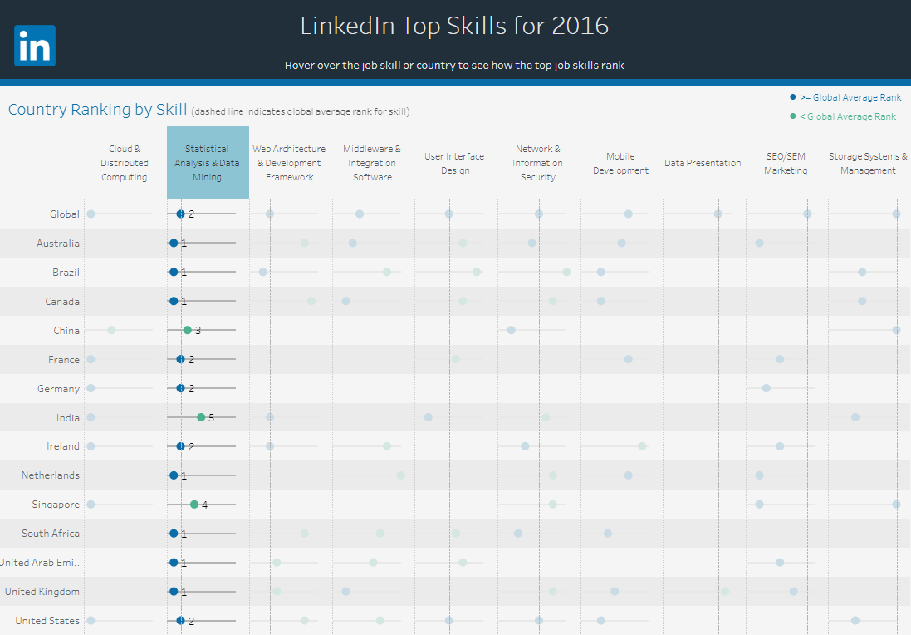

Insight #1: after clicking on the “Statistical Analysis & Data Mining”, it shows this skill ranked No.2 globally. Countries that ranked this skill top 1 within their countries are: Australia, Brazil, Canada, Netherlands, South Africa, United Arab Emi, United Kingdom. The rest of the 14 countries ranked this skill from No.2 to No.5.

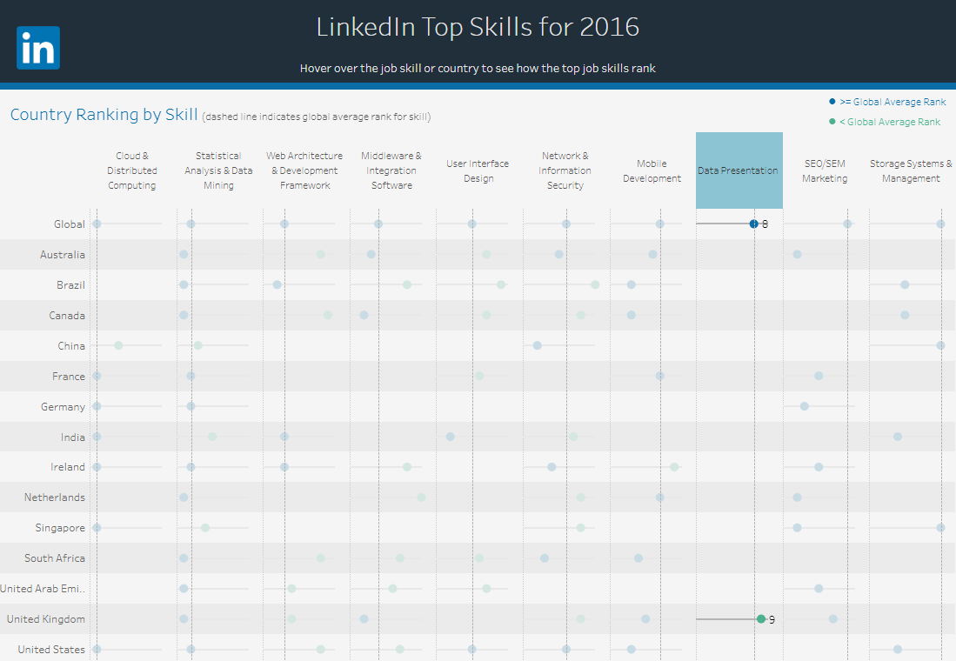

Insight #2: after clicking on “Data Presentation”, only one country among the 14 countries that tops this skill. That country is United Kingdom. Global wise, this skill is ranked at No.8. And in UK, this skill is ranked at No. 9.

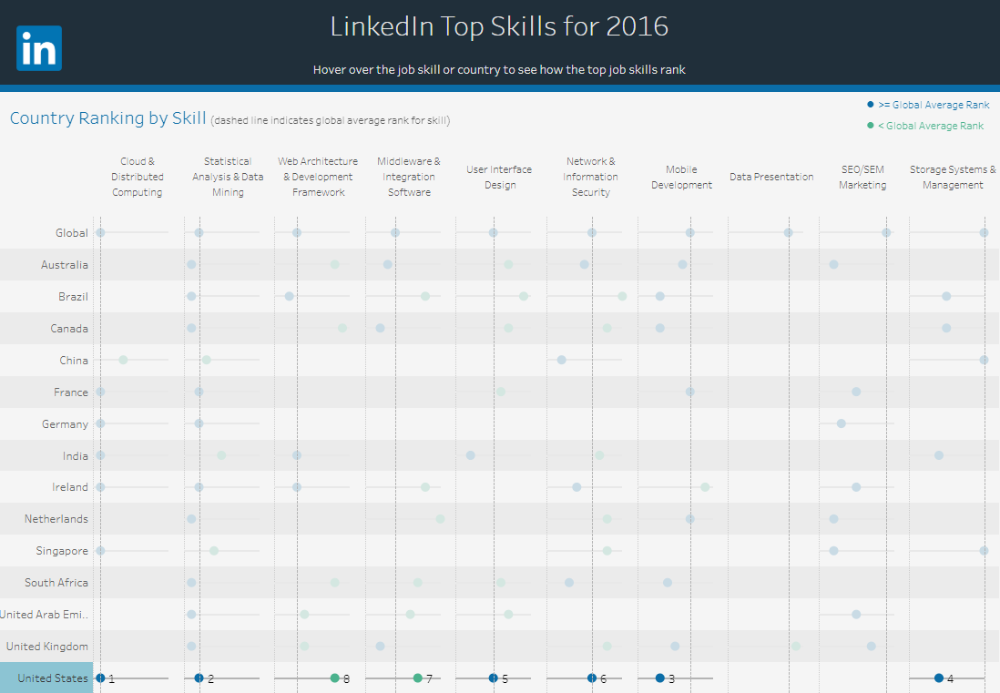

Insight #3: After clicking on the “United States”, it shows US skills from Top 1 to Top 8 are ALL listed here, among the LinkedIn top skills for 2016. Top 1 and top 2 skills in US are also top 1 and top 2 skills in LinkedIn. They are: Cloud & Distributed Computing, Statistical Analysis & Data Mining.